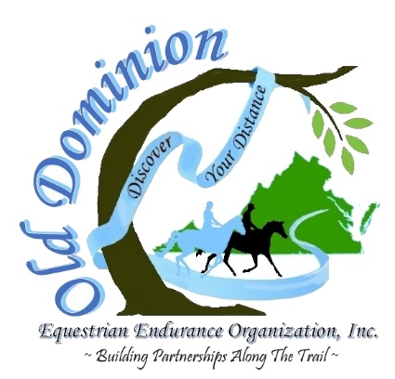
Old Dominion Equestrian Endurance
Organization, Inc. Membership Form

Annual membership is January – December.
Please note: Applications received up to October 31
will be applied to current year only.

Name:
Family Members:
 |  | (Fill in for Family Membership only)
Address:
City: |  |  |  |  | State: |  |  | Zip Code:
Phone: |  |  |  |  | Cell:
Email: |  |  |  |  | and
 |  | (Please print clearly)
Annual Membership: |  | Individual ($25 – 1 vote) |  |  |  | Family ($35 – 2 votes)
Lifetime Membership: |  | Individual ($400 – 1 vote forever) |  |  |  | Family ($500 – 2 votes forever)
PayPal. Payment@ODEEO.org. Please send your completed membership form to the below email.
Check is enclosed. |  | Credit Card payment this year only. |  |  |  |  | Automatically renew.
Name on the Card:
Card Type: | Visa |  | MasterCard |  | American Express |  |  | Discover
Card Number: |  |  |  |  | Expiration Date:
Card 3-Digital CID Code (found on the back): |  |  |  |  | _________
I would like to volunteer to help at: |  |  |  | rides |  | clinics |  | other events
I agree to uphold and adhere to the rules of the Old Dominion Equestrian Endurance Organization, Inc.
Signature: |  |  |  |  |  | Date:
Checks should be made payable to “Old Dominion Equestrian Endurance Organization, Inc.”
Please send completed membership form and check to:
Old Dominion Equestrian Endurance Organization, Inc.
16813 Clarkes Gap Road
Paeonian Springs, VA 20129
or send membership form (if paid through PayPal) by email to Treasurer@ODEEO.org.
For Questions, Contact: (540) 554-2004 or email: give2bute@aol.com
www.OldDominionRides.org

